PIZZA SALES SQL QUERIES
A. KPI’s
1. Total Revenue:
SELECT ROUND(SUM(total_price),2) AS Total_Revenue FROM pizzasales;
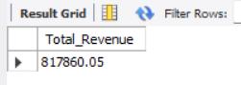
2. Average order values
SELECT ROUND(SUM(total_price)/COUNT(DISTINCT order_id), 2) AS AverageOrder FROM pizzasales;
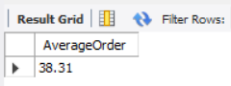
3. Total Pizza Sold
SELECT SUM(quantity) AS Pizza_Sold FROM pizzasales;
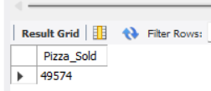
4. Total Orders Placed
SELECT COUNT(DISTINCT order_id) AS Total_Orders FROM pizzasales;
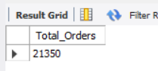
5. Average pizzas per order
SELECT ROUND(SUM(quantity)/COUNT(DISTINCT order_id),2) AS AvgPizzaPerOrder FROM pizzasales;
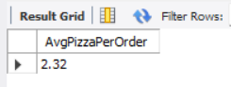
Total numbers of orders in each week
SELECT DAYNAME(order_date) AS order_day,
COUNT(DISTINCT order_id) AS Total_Orders
FROM pizzasales
GROUP BY DAYNAME(order_date) ORDER BY COUNT(DISTINCT order_id) desc;
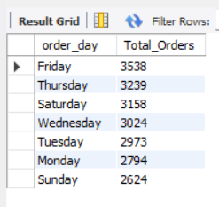

-- Total numbers of orders in each Month
SELECT monthname(order_date) AS order_month,
COUNT(DISTINCT order_id) AS Total_Orders
FROM pizzasales
GROUP BY monthname(order_date) ORDER BY COUNT(DISTINCT order_id) desc;
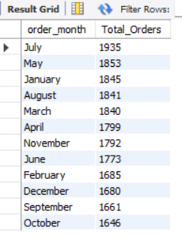

-- Percentage of Sales by Pizza Category
SELECT pizza_category, ROUND(SUM(total_price),2) AS Total_Price,
ROUND((SUM(total_price)*100)/(SELECT SUM(total_price) FROM pizzasales), 2) AS Total_Sales
FROM pizzasales GROUP BY pizza_category;
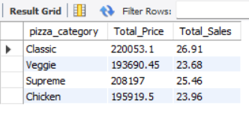
If we want to filter data by month wise we can also do that:
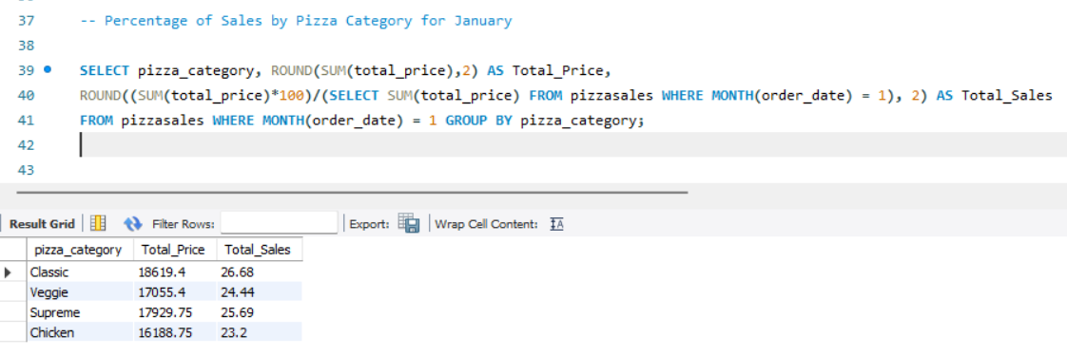

-- Percentage of sales by Pizza Size
SELECT pizza_size, ROUND(SUM(total_price),2) AS Total_Price,
ROUND((SUM(total_price)*100)/(SELECT SUM(total_price) FROM pizzasales), 2) AS Total_Sales
FROM pizzasales GROUP BY pizza_size;
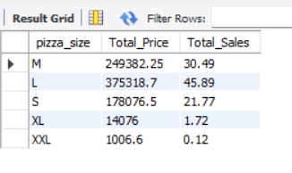
-- Top 5 best sellers by revenue
SELECT pizza_name, SUM(total_price) AS Total_revenue FROM pizzasales
GROUP BY pizza_name ORDER BY Total_revenue desc LIMIT 5;
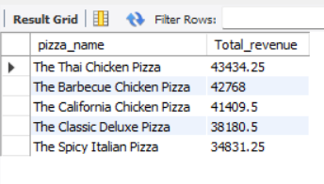
-- Bottom 5 best sellers by revenue
SELECT pizza_name, SUM(total_price) AS Total_revenue FROM pizzasales
GROUP BY pizza_name ORDER BY Total_revenue asc LIMIT 5;
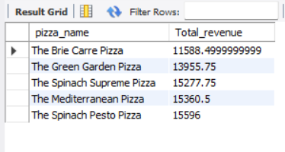

-- Top 5 best sellers by quantity
SELECT pizza_name, SUM(quantity) AS Total_Quantity FROM pizzasales
GROUP BY pizza_name ORDER BY Total_Quantity desc LIMIT 5;
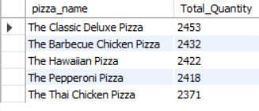
-- Bottom 5 best sellers by quantity
SELECT pizza_name, SUM(quantity) AS Total_Quantity FROM pizzasales
GROUP BY pizza_name ORDER BY Total_Quantity asc LIMIT 5; 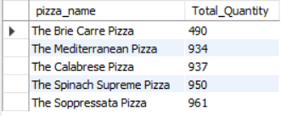
-- Top 5 best sellers by orders
SELECT pizza_name, COUNT(DISTINCT order_id) AS Total_Order FROM pizzasales
GROUP BY pizza_name ORDER BY Total_Order desc LIMIT 5;
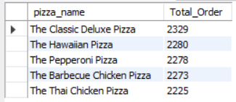

-- Bottom 5 best sellers by orders
SELECT pizza_name, COUNT(DISTINCT order_id) AS Total_Order FROM pizzasales
GROUP BY pizza_name ORDER BY Total_Order asc LIMIT 5;
